

### A REPORT ON

**Online Ordering System**

Is Submitted in Partial Fulfillment of The Requirements for the Degree of Third Year OF ENGINEERING

In

COMPUTER ENGINEERING DEPARTMRNT By

**Vivek Ganesh Jadhao**

**Roll No - 13167**

**Under the Guidance of Prof. Ashok Patil**

DEPARTMENT OF COMPUTER ENGINEERING

## Dr. D. Y. Patil College of Engineering and Innovation Varale, Talegaon-410507

**T.E Sem-II, 2021-2022**



DR.D.Y.PATIL COLLEGE OF ENGINEERING AND INNOVATION

**DEPARTMENT OF COMPUTER ENGINEERING**



## DR.D.Y.PATIL COLLEGE OF ENGINEERING AND INNOVATION

#### DEPARTMENT OF COMPUTER ENGINEERING

**CERTIFICATE**

This is to certify that Vivek Ganesh Jadhao of T.E. Computer Engineering,

Roll No. 13167 has successfully completed his report on “Online Ordering System”.

To my satisfaction and is submitted the same during the academic year 2021-22 semester towards the partial fulfillment of degree of Bachelor of Engineering under the Savitribai Phule Pune University, Pune.

**Date**: / / 2022

**Place**: Talegaon, Pune

Prof. Ashok Patil Dr. Alpana P. Adsul

#### Subject Guide HOD

Prof. Ashok Patil Dr. S. N. Mali

#### Subject Coordinator Principal

**Index**

|  |  |  |
| --- | --- | --- |
| **Sr. No** | **Name of Activity** | **Page No** |
| 1 | Introduction | 1 |
| 2 | Objective | 2 |
| 3  4  5  6  7  8 | Tools used Algorithm  Data Flow Diagram Use Case Diagram ER-Diagram  Implementation Details | 3  4  5  5  6  7 |
| 9 | Screenshots | 8 |
| 10 | Conclusion | 10 |
| 11 | References | 11 |

# INTRODUCTION

In this emerging world of computers, almost all-manual system has switched to automated and computerized system. Therefore, we are developing the software for “Online Ordering System” to model the present system and to remove the drawbacks of the present system. This project explores how computer technology can be used to solve the problem of user. This being a big step in terms of improvement in the railway system it is widely accepted across the country. Rather than designing manually, we have made use of computer. Use of computer has solved many problems, which are faced during manual calculation. Once data are fed, it can perform accurate functions. Therefore, to reduce the complexity and efficiency a versatile and an outsourcing railway reservation system has been developed.

In a modern generation Online customers ordering is a mobility of customers delivery or takeout from a local restaurant or customers cooperative. Now days the rapid growth in the use of internet and the technologies associated with it, the several opportunities are coming up on the web or mobile application. This is made possible through the use of electronic payment system. The payment can be done through the customer’s credit card, debit card. It is possible for everyone to order any goods from anywhere the internet and have the goods delivered at his/her home. All types made be internet le transaction ads to the economic of digital cash, the necessary tool for this process telecommunication with customers. The system will become an important tools use for restaurant to improve the management aspect by use of computer system to connected each and every customers ordering transaction instead of data record on it. In addition, it can also provide efficiency for the restaurant by reducing time consuming, minimize human errors or delivery and providing good quality and service to customers. In terms of the integrity and availability of the system provided, it can be concluded that this system is a suitable solution.

# Objectives

Based on the problem stated above, the objectives of the project are :

1. To develop online ordering and reservation system in restaurant.
2. To develop use interface for online restaurant management system.
3. To provide online menu information for customer.
4. Increase sales and productivity by knowing the status of all restocking and special orders.
5. Get better prices from vendors by ordering smarter, leveraging detailed purchase history
6. Increase profitability by eliminating unnecessary and wasteful purchases.
7. Increase efficiency through detailed reporting.

**Tool Used**

#### Software Requirements -

* Software’s used : - Visual Studio Code
* Operating system: - We have chosen Windows 10 operating system
* Database : - MySQL
* Salesforce.com:- Salesforce started as Software as a Service (SaaS) CRM company. Salesforce now provides various software solutions and a platform for users and developers to develop and distribute custom software. Salesforce.com is based on multi- tenant architecture.[1]

#### Hardware Requirements -

* Processor :- Pentium or Higher
* RAM :- 4 GB
* Hard Disk :- 500 GB
* Input Device :- Keyboard, Mouse

**Algorithm -**

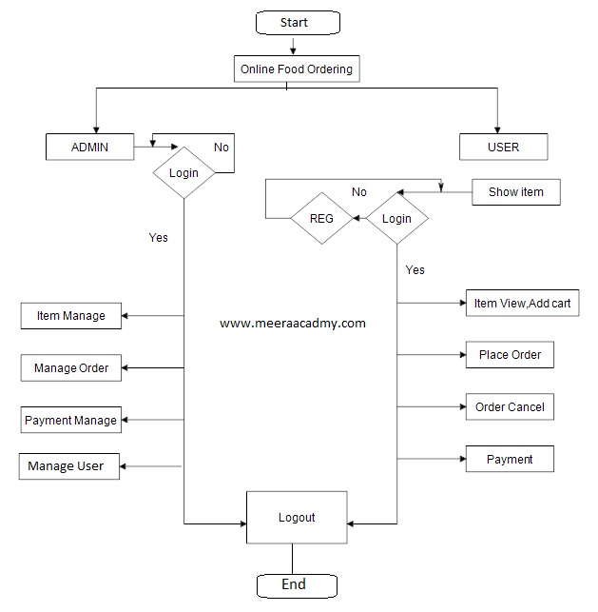

**Figure : Algorithm for Online Ordering System**

### Data Flow Diagrams -

##### DFD LEVEL 0 –

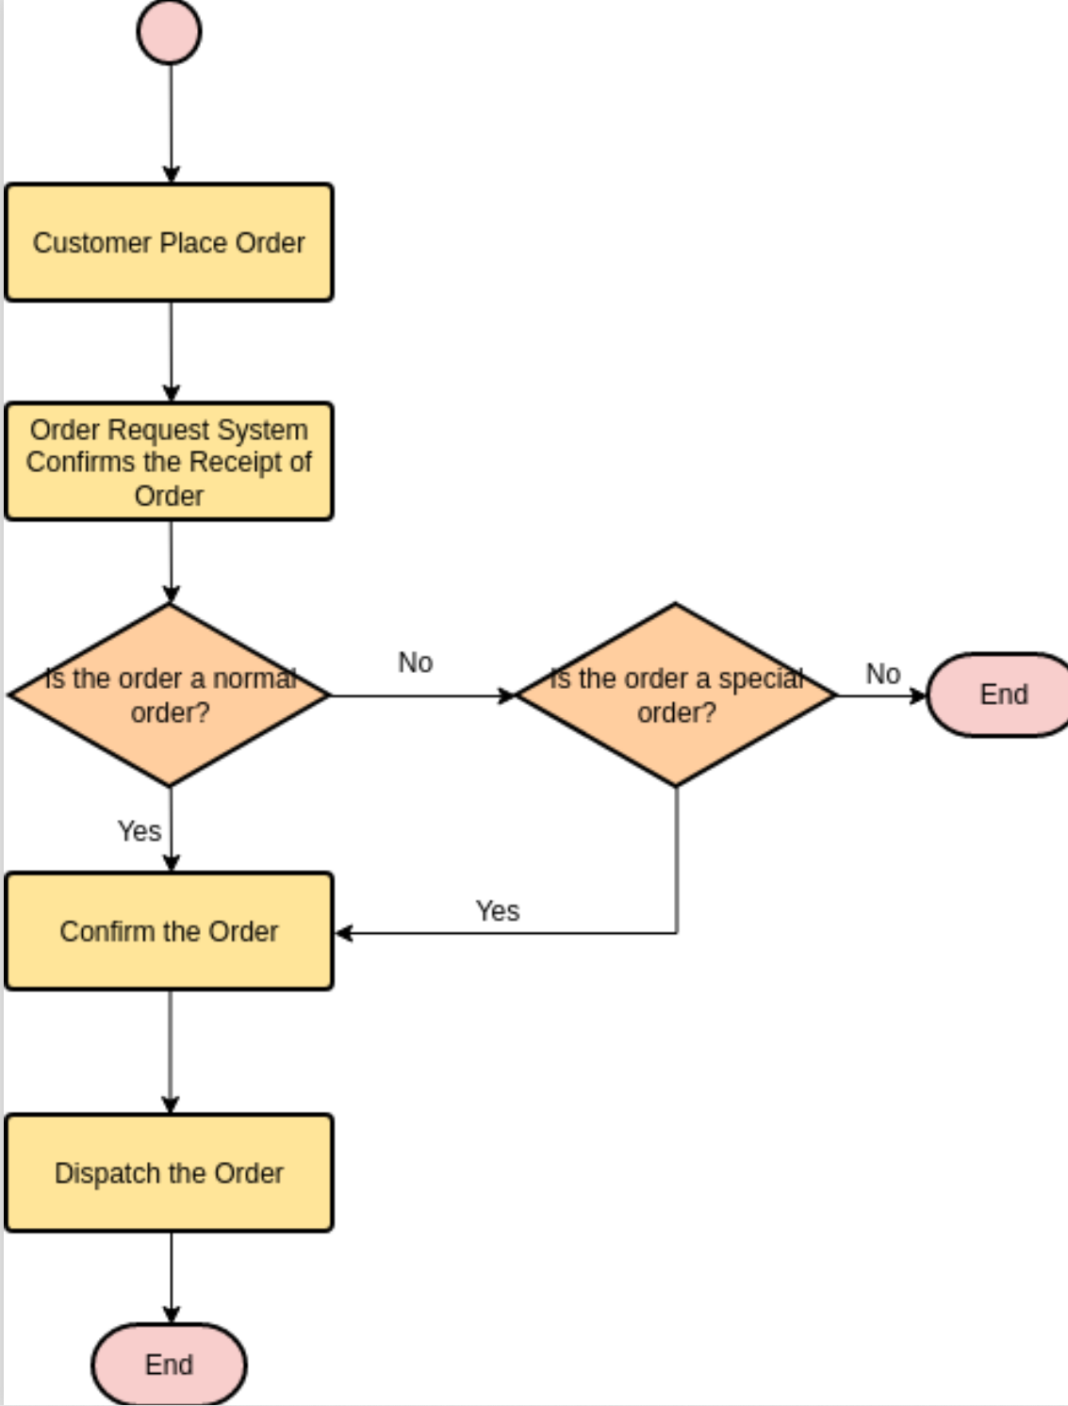

**Figure : DFD Level 0 for Online Ordering System**

**Entity Relationship Diagram**

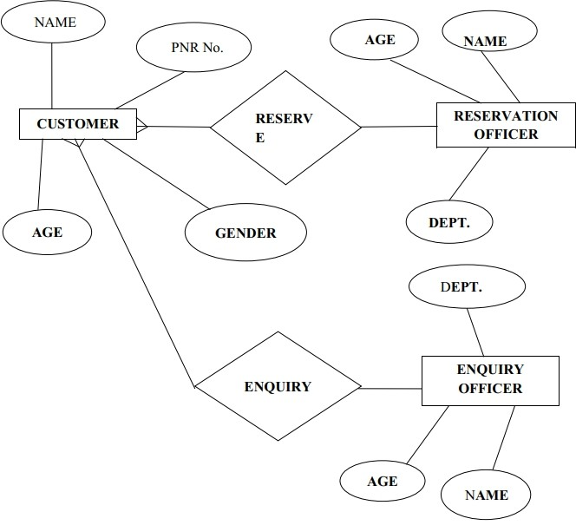

**Figure : ER- Diagram for Online Ordering System**

### Implementation Details:

**Salesforce:**

Salesforce is a cloud computing service as a software (SaaS) company that specializes in customer relationship management (CRM). Salesforce's services allow businesses to use cloud technology to better connect with customers, partners and potential customers. The software has become the number one for customer success and helps businesses track customer activity, market to customers and many more services.[1]

##### What is Salesforce Developer Console?

Salesforce Developer Console is a browser based developing environment which is used to Create, test and debug application in salesforce organization. Using salesforce developer console we can and edit execute SOQL and SOSL queries.[2]

* Apex is an object-oriented and strongly typed programming language developed by Salesforce for building Software as a Service (SaaS) and Customer Relationship Management (CRM).[1]
* Salesforce Apex is designed to process large amounts of data to add business logic to applications and to write Controller in the MVC architecture.
* Apex is an object oriented language similar to C# and Java that allows to implement complex business requirements and transactions on the force.com platform.

### Implementing Salesforce:

##### How to use Salesforce Developer Console?

1. **To open Salesforce Developer Console, navigate to Name | Developer console.**

##### Now developer Console will be opened with menu bar, Workspace and log menu. Using developer console in Salesforce we can create Apex Class, Apex Trigger, Visualforce page, Visualforce Component, Static resources, Lightning application and many more as show below.

1. **To create new Visualforce page in Salesforce developer console navigate to File | New | Visualforce page.**

##### Now in Workspace enter Apex code and Save the Code.

1. **To execute apex code click on Preview button and a new window with visualforce page result will be opened in new window.**

### Result: Screenshot:

##### Home Page –

**About Page –**

**Figure : Home page of Online Ordering System**

##### Services Page –

**Figure : About page of Online Ordering System**

**Figure : Services page for Online Ordering System**

##### Reservation Page –

**Figure : Reservation page for Online Ordering System**

##### Contact Page -

**Figure : Contact page for Online Ordering System**

**After Filling Contact Details –**

**Figure : Pop-up for Online Ordering System**

# Conclusion

The Online Ordering System system facilitates the customers to enquiry about the dishes available on the basis of source and destination, booking and cancellation of foods, enquiry about the status of the booked food, etc. The aim of case study is to design and develop a data base maintaining records of different dishes, dish status and customers. This project contains introduction to the railways reservation system. It is the computerized system of reserving the platesof dish platesin advance. It is mainly used for a long route. Online reservation has made the process for the reservation of platesvery much easier than ever before.[5]

* To design a Online Ordering System website of a particular agency using information collected through internet.[6]
* To design a website which integrates all the information needed by user
* To make the website user friendly.
* To allow the user to search food according to his needs
* The user can specify the location where he wants the food.
* To save user ‘s time by allowing easy access to the site
* Shortens the time between data collection and data analysis.
* Reduces workload
* An advanced yet handy tool with an easy-to-use interface.
* Quickly and easily manages property listings.
* Contributes hugely in saving the time and enhances data quality.
* Data inconsistency almost eliminated
* Storage requirement highly reduced

# References

* 1. Salesforce for Beginners: A step-by-step guide to creating, managing, and automating sales and marketing processes, Publisher : Packt Publishing Limited (29 May 2020), ISBN-13 : 978- 1838986094
  2. MySQL: The Complete Reference, Author Vikram Vaswani, Publisher McGraw Hill Professional,2004, ISBN0071782435,9780071782432
  3. Visual Studio Code End-to-End Editing and Debugging Tools for Web Developers, Author:Bruce Johnso, Publisher:Wiley, ISBN:9781119588214, 1119588219
  4. HTML, CSS, and JavaScript All in One, Sams Teach Yourself Authors : Julie C. Meloni, Jennifer Kyrnin, Publisher Sams Publishing, 2018, ISBN 0135167078, 9780135167076
  5. Digitalising Online Ordering System System, Author : Dr. Adv. Harshul Savla, Publisher : Notion Press; 1st edition (2 November 2021), ISBN-13 : 978-1685389987
  6. All About Railway Food Reservation, Author: Brandon Turner, Publisher : BiggerPockets Publishing; 1st edition (1 December 2015) ASIN : B018UTI2DO